SQL Mega Project:-

Basics and Intermediate

Project Type(A)



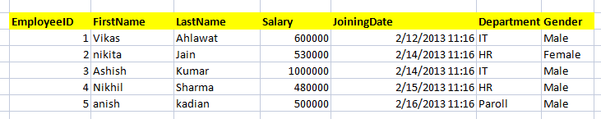

1) Write a query to get all employee detail from "EmployeeDetail" table



2) Write a query to get only "FirstName" column from "EmployeeDetail" table



3) Write a query to get FirstName in upper case as "First Name".

4) Write a query to get FirstName in upper case as "First Name".



5) Write a query for combine FirstName and LastName and display it as "Name" (also include white space between first name & last name)



1. Select employee detail whose name is "Vikas
2. Get all employee detail from EmployeeDetail table whose "FirstName" start with latter 'a'.



8) Get all employee detail from EmployeeDetail table whose "FirstName" start with latter 'a'.

1. Get all employee details from EmployeeDetail table whose "FirstName" end with 'h'



1. Get all employee detail from EmployeeDetail table whose "FirstName" start with any single character between 'a-p'



1. Get all employee detail from EmployeeDetail table whose "FirstName" not start with any single character between 'a-p'



1. Get all employee detail from EmployeeDetail table whose "Gender" end with 'le' and contain 4 letters. The Underscore(_) Wildcard Character represents any single character



1. Get all employee detail from EmployeeDetail table whose "FirstName" start with 'A' and contain 5 letters



1. Get all employee detail from EmployeeDetail table whose "FirstName" containing '%'. ex:-"Vik%as".



1. Get all unique "Department" from EmployeeDetail table
2. Get the highest "Salary" from EmployeeDetail table.



1. Get the lowest "Salary" from EmployeeDetail table
2. Show "JoiningDate" in "dd mmm yyyy" format, ex- "15 Feb 2013
3. Show "JoiningDate" in "yyyy/mm/dd" format, ex- "2013/02/15"



1. Show only time part of the "JoiningDate"



1. Get only Year part of "JoiningDate"



1. Get only Month part of "JoiningDate”



1. Get system date



1. Get UTC date.



* 1. Get the first name, current date, joiningdate and diff between current date and joining date in months.



1. Get the first name, current date, joiningdate and diff between current date and joining date in days.
2. Get all employee details from EmployeeDetail table whose joining year is 2013



1. Get all employee details from EmployeeDetail table whose joining month is Jan(1)



1. Get all employee details from EmployeeDetail table whose joining month is Jan(1)



1. Get how many employee exist in "EmployeeDetail" table



1. Select only one/top 1 record from "EmployeeDetail" table



1. Select all employee detail with First name "Vikas","Ashish", and "Nikhil".



1. Select all employee detail with First name not in "Vikas","Ashish", and "Nikhil"



1. Select first name from "EmployeeDetail" table after removing white spaces from right side
2. Select first name from "EmployeeDetail" table after removing white spaces from left side



1. Display first name and Gender as M/F.(if male then M, if Female then F)



1. Select first name from "EmployeeDetail" table prifixed with "Hello



1. Get employee details from "EmployeeDetail" table whose Salary greater than 600000



1. Get employee details from "EmployeeDetail" table whose Salary less than 700000



1. Get employee details from "EmployeeDetail" table whose Salary between 500000 than 600000



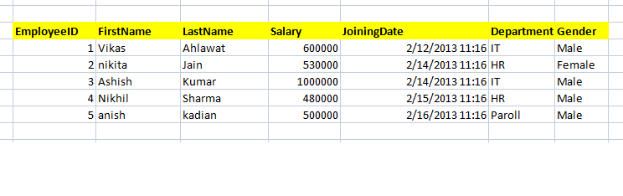

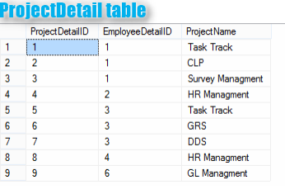

1. Give records of ProjectDetail table



1. Write the query to get the department and department wise total(sum) salary from "EmployeeDetail" table.
2. Write the query to get the department and department wise total(sum) salary, display it in ascending order according to salary.



1. Write the query to get the department and department wise total(sum) salary, display it in descending order according to salary



1. Write the query to get the department, total no. of departments, total(sum) salary with respect to department from "EmployeeDetail" table.



1. Get department wise average salary from "EmployeeDetail" table order by salary ascending

47 . Get department wise maximum salary from "EmployeeDetail" table order by salary ascending



48.Get department wise minimum salary from "EmployeeDetail" table order by salary ascending.



1. Get department wise minimum salary from "EmployeeDetail" table order by salary ascending



1. Join both the table that is Employee and ProjectDetail based on some common paramter
2. Get employee name, project name order by firstname from "EmployeeDetail" and "ProjectDetail" for those employee which have assigned project already.



1. Get employee name, project name order by firstname from "EmployeeDetail" and "ProjectDetail" for all employee even they have not assigned project.



1. Get employee name, project name order by firstname from "EmployeeDetail" and "ProjectDetail" for all employee if project is not assigned then display "-No Project Assigned"

54.Get all project name even they have not matching any employeeid, in left table, order by firstname from "EmployeeDetail" and "ProjectDetail



1. Get complete record (employeename, project name) from both tables ([EmployeeDetail],[ProjectDetail]), if no match found in any table then show NULL



1. Get complete record (employeename, project name) from both tables ([EmployeeDetail],[ProjectDetail]), if no match found in any table then show NULL



57.Get complete record (employeename, project name) from both tables ([EmployeeDetail],[ProjectDetail]), if no match found in any table then show NULL



58.Write down the query to fetch EmployeeName & Project who has assign more than one project



1. Write down the query to fetch ProjectName on which more than one employee are working along with EmployeeName



1. Apply Cross Join in Both the tables



Advanced:-

Project Type(B):-







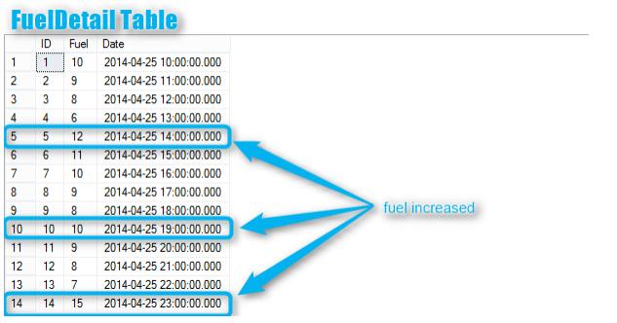

1. Write down the query to print first letter of a Name in Upper Case and all other letter in Lower Case.(EmployDetail table)



1. 1. Write down the query to display all employee name in one cell seprated by ',' ex:-"Vikas, nikita, Ashish, Nikhil , anish"(EmployDetail table)



1. Write down the query to get ProjectName and respective EmployeeName(firstname) which are working on the project, --if more then one employee working on same project, then it should be in same cell seprated by comma



--for example :- Task Tracker : Vikas, Ashish



1. : You have a table(FuelDetail) with ID, Fuel, And Date columns. --Fuel column is contain fuel quantity at a particular time when car start traveling.

So we need to find out that when the driver fill Petrol in his/her car.

--By FuelDetail Table image on the top of this post, you can understand the query.

--Car start driving at 10 Am on 25th April with petrol(10 liter)

--at 11 AM Petrol was 9 liters

--at 12 AM petrol was 8 liters

--at 2 PM (14) petrol was 12 liters...

--This means that he/she fill the petrol at 25th April 2014 at 2PM --Next time he fill petrol at 7PM 25th April 2014

--and Next time he fill petrol at 11PM 25th April 2014

5.What would be the out-put of the following Sql query?



SELECT A.A FROM (SELECT 1 A, 2 B) A JOIN (SELECT 1 A,1 B)B ON A.A = B.B

Options:

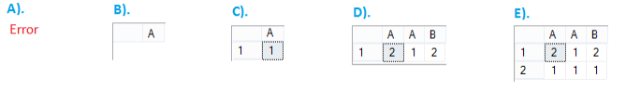



1. What would be the out-put of the following Sql query?



SELECT B.A FROM (SELECT 1 A) A JOIN (SELECT 1 A, 2 B)B ON A.A = B.A Options:

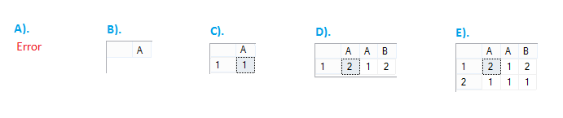



1. What would be the out-put of the following Sql query?

SELECT B.A FROM (SELECT 1 A) A JOIN (SELECT 1 A, 2 B)B ON A.A = B.B Options:

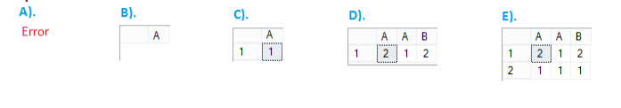



1. What would be the out-put of the following Sql query? SELECT * FROM (SELECT 1 A UNION ALL SELECT 2 B) A JOIN (SELECT 1 A,2 B)B ON A.A = B.B

Options:

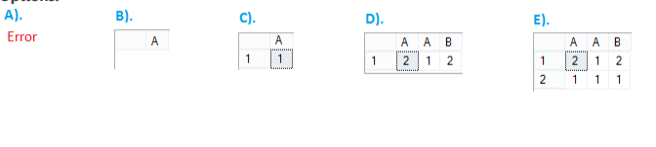



Advanced:-

Project Type©(Syntax Based Project):-

Write a Syntax queries of All Questions:-

1. How to select random record form a table?



1. Suppose that you have table Employee with a column EName which contain Records Employee name(EName) as A,B,A,A,B,D,C,M,A, Write a query which will change/Swap the EName A to B and B to A



1. Write a query to create a clone of existing table without using Create Command



1. Table Tbl1 has 100 rows, Table Tbl2 has 0 rows so number of rows returned by the below query?



1. Write a query to print 1 to 100 in sql server without using loops
2. You have two tables with blank value in both table as shown in below image, Then what would be the output of the following Query based on the tables shown in image?



1. What will be the output of the following query?



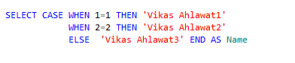



1. What is the purpose of the WITH SCHEMABINDING clause and where can it be used?



1. What is an Index?



1. Write the T-Sql statement/syntex for create and index

